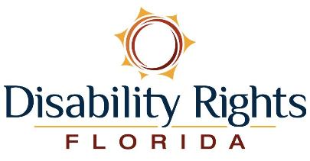

2022 Annual Report

Letter From Our Leadership
For the past 46 years, Disability Rights Florida (DRF) has been advocating and protecting the rights of children and adults with disabilities to live as they choose, free from abuse, neglect, and discrimination. This past year alone, we received calls from 8,289 people looking for help. Our knowledgeable Intake Team provided them with information, advice, or referral, and our dedicated legal teams took on 1,760 new cases focused on rights violations that adversely affect people with disabilities.
The issues we addressed for our individual clients included access and accountability in healthcare, housing, education, employment, community integration, mental health services and more. We helped individuals like Christopher convince his Vocational Rehabilitation Counselor to allow him to pursue an education to become an anesthesiologist by strengthening his academic and employment plan. And we advocated for Lorenzo’s family with the Agency for Persons with Disabilities to have their bathroom modified for his wheelchair.
In 2022, our attorneys and advocates also successfully fought for systemic reforms that affected thousands of Floridians with disabilities, including students who were not receiving a Free and Appropriate Public Education, renters who needed housing that is accessible for wheelchairs and other mobility devices, and individuals who have been involuntarily confined to mental health institutions and deserve the right to face a judge in person. We monitored the development of state agency rules that affect people with disabilities, and, if the proposed rule adversely affected people who have disabilities, we intervened.
DRF used its legal authority to visit and monitor mental health facilities, group homes, nursing homes, State prisons, and county jails to determine if people with disabilities were being subjected to abuse, neglect, exploitation, or other rights violations. Some of these visits were the result of orders obtained by DRF in court.
DRF’s mission includes providing information and education to people with disabilities, their families, and the public through awareness and outreach events. This year we attended 79 events statewide, to speak to more than 6,500 people about their rights, our services, and how to effectively engage in their own self-advocacy efforts. We also conducted five public forums across the state to collect input that helped shape our goals and priorities.
We are proud of the work we have accomplished this year. Our legal staff, Public Policy and Rep Payee professionals, administrative staff, Board of Directors, and PAIMI Advisory Council are fully committed to our mission and are always acutely aware that what we do affects so many. We hope you’ll be inspired to connect with us, share your ideas, and let us know what is important to you. We have so much more to accomplish as we protect and advance the rights, dignity, equal opportunities, self-determination, and choices for all people with disabilities.
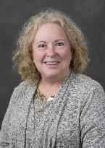 | 
Virginia Daire  Board Chair | Peter Sleasman  Executive Director

Annual Report and Other Publications Available Online
Our 2022 Annual Report is also available online in both PDF and Microsoft Word formats. The Word format has a more linear and accessible layout. Visit www.DisabilityRightsFlorida.org/AnnualReport or scan the QR code below to access both versions and download other publications available, such as these:
- Disability Rights Florida Brochure
- Protection and Advocacy for Beneficiaries of Social Security Program
- Supporting Individuals with Mental Health Conditions
- Ten Steps to Effective Self-Advocacy
- Accessible Voting
- Client Assistance Program
- Are You Prepared for an Emergency?
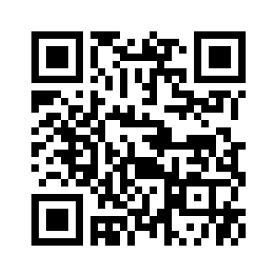

Highlighting Artists with Disabilities
Wheelchair Highwaymen
This year’s annual report features the photo “Ada’s Fairytale” by the Wheelchair Highwaymen.
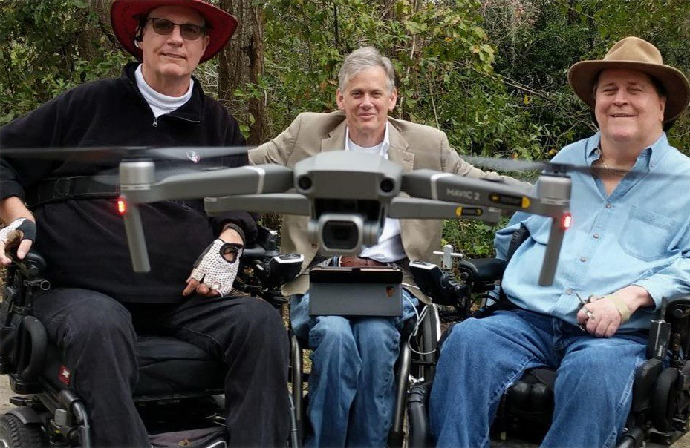
From left to right: J.R. Harding, Max Lee, Gordon Palmer
The Wheelchair Highwaymen are Florida nature photographers bringing nature back into the lives of people with disabilities through technology. The daily challenges they face and overcome have not stopped them from searching for and capturing these beautiful moments. Their goal is to use drone technology, photography, and nature to inspire and enrich the lives of individuals with and without disabilities. With your support, they hope to photograph other natural wonders throughout their beloved Florida and other areas.


“Ada’s Fairytale” by the Wheelchair Highwaymen

Client Success Stories

Staff Advocacy Leads to Successful Transition
Ariana is a 26-year-old with emotional and behavioral disabilities. After the Agency for Persons with Disabilities (APD) denied her crisis enrollment to the iBudget waiver, her parents contacted us for help. APD crisis enrollment provides individuals with disabilities in serious situations support faster, instead of staying on the waitlist. We worked closely with her family to advocate for Ariana until the APD agreed to enroll her to the waiver. She was able to successfully transition to a group home where she is thriving, involved in hobbies, making friends, and living in a community of folks that support her.
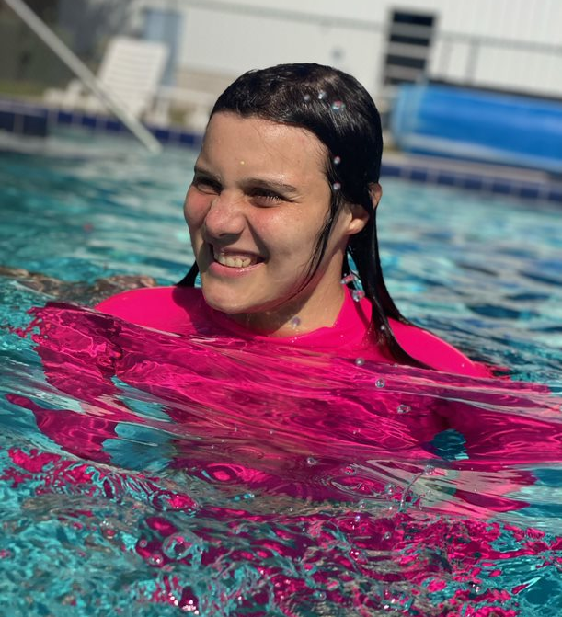

Accessible Shower Renovation Made a Reality
Lorenzo is a wheelchair user with Cerebral Palsy who faced access barriers in his bathroom. For it to be accessible, he needed a roll-in shower, special door, and re-tiled floor. His mom reached out to the Agency for Persons with Disabilities (APD) to get their bathroom modification covered. Lorenzo and his family tried to get the renovation approved by APD for two years but were consistently denied due to monetary and staffing reasons. That’s when his mom reached out to us to help cut through the red tape. We worked with the family and the APD to submit supportive paperwork emphasizing the need for a modified shower. With the new request and documents, the renovation project was approved!
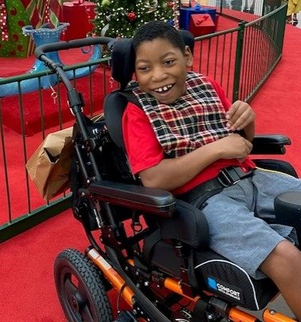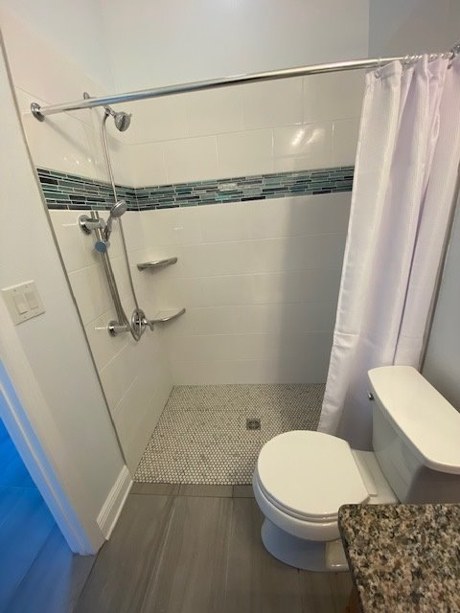

Bringing Much-Needed Disability Representation to our Healthcare Settings
With aspirations to become an anesthesiologist, Christopher, an individual with a neurodevelopmental condition, pursued an Individualized Plan for Employment with a Vocational Rehabilitation Counselor (VRC). Unfortunately, he encountered barriers when his VRC would not agree to Christopher’s job goal or help him create a plan to become an anesthesiologist. Christopher reached out to us for assistance, and we helped him make a meaningful academic and employment plan. Now, Christopher is on his way to becoming an anesthesiologist with encouragement from his new supportive VRC. People with disabilities deserve the same competitive and integrated employment opportunities as their non-disabled peers, and we’re proud to help break down employment barriers for our clients.
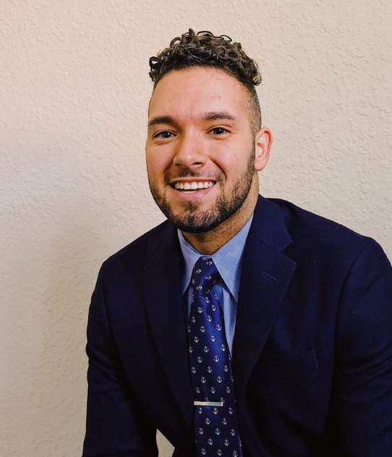

Accessible Walkway Offers Reassurance and Independence
Carmina is an individual with mobility impairments living in South Florida. She contacted us because she needed an assigned parking space close to her condominium unit, as well as handrails and anon-slip coating along an inclined walkway. Our staff made requests to her condominium association for reasonable accommodation and modification, and we contacted the Center for Independent Living (CIL) of Broward to pay for the cost of the materials and labor to install the accessible walkway. We worked closely with these groups to ensure they completed the renovation. We’re glad to share that Carmina now has the parking space and ADA-compliant walkway with handrails and non-slip surface she needs to safely access her home.
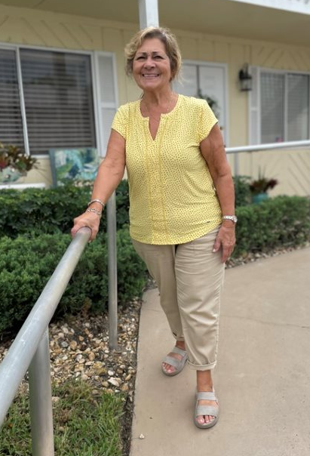

DRF Investigation Demands Compliance and Transparency from The Florida Department of Corrections in Mental Health Care
For the past few years, Disability Rights Florida (DRF) has been monitoring the Florida Department of Corrections’ (FDC) inpatient mental health units to ensure that the inmates with mental health conditions placed there are safe and are receiving appropriate mental health care as required by law. Our investigations began in 2015 when DRF brought litigation against one institution that was found to be woefully out of compliance with the law, creating a dangerous environment for inmates with mental health conditions. After we demanded compliance and saw improvements actively making this facility safer, we also became aware of the statewide systemic issues involving FDC’s inpatient mental health units. In 2018, our staff took further action in order to address mental health care at all eight FDC locations. Over the past five years, we’ve consistently monitored these eight facilities, demanding that the FDC bring three main lacking components of patient care into compliance.
- The first aspect is staffing. Currently, understaffing is a significant issue, limiting the staff’s capability to provide care. Alternatively, if they employ fully staffed treatment teams featuring mental health professionals, nurses, social workers, and law enforcement, the facility will have the personnel to appropriately assist patients, implement their care plans, and provide meaningful mental health care and interventions.
- The second component is structured and unstructured activity time. We found that patients were not getting sufficient activity time indoors or outdoors, which is their only time to get exercise and sunlight. Patients were also not getting structured group treatment time. To comply, staff members must lead consistent in-person group sessions and ensure that patients have sufficient activity time.
- The final aspect of compliance is medical care. Staff members were not following up on critical medical tests, inaccurately documenting health records, and inadequately implementing patient care plans. To ensure patient safety and well-being, comprehensive and consistent medical documentation and supervision are imperative.
To assess FDC’s compliance, independent monitors reviewed medical records, interviewed staff and patients, observed care team meetings, analyzed staffing statistics, and documented patient activity. After evaluating the facilities, the monitors scored each unit using an agreed rating system, with a rating of 100% being fully compliant. To reach our expected level of compliance, the units needed a rating of 80%. After our most recent monitoring, we found six of the eight facilities did not implement necessary changes and scored below 80% compliance. A score below 80% warrants great concern because this indicates over 20% of patient care and safety is falling through the cracks. Because of this lack of compliance, we will continue to monitor these six units for the next two years.
DRF is committed to protecting the lives of those with disabilities and ensuring they can access meaningful mental health care. We will continue to oversee FDC’s compliance to ensure inmates with mental health conditions have the constitutionally required level of care to which they are entitled.

Accessible Voting Videos
As we prepared for the 2022 Midterm Elections, we promoted educational voting videos by and for people with disabilities. Our video project, titled “Florida’s Accessible Voting Machines,” explains how the two commonly used accessible voting machines, ImageCast and Express Vote, work. Additionally, these videos discuss how to exercise your civil rights in an accessible way and emphasize the power of the disability vote. These videos brought awareness of accessible voting options to over 25,000 Floridians. Learn about your rights and options through these videos on the “Access the Vote Florida” coalition’s website.
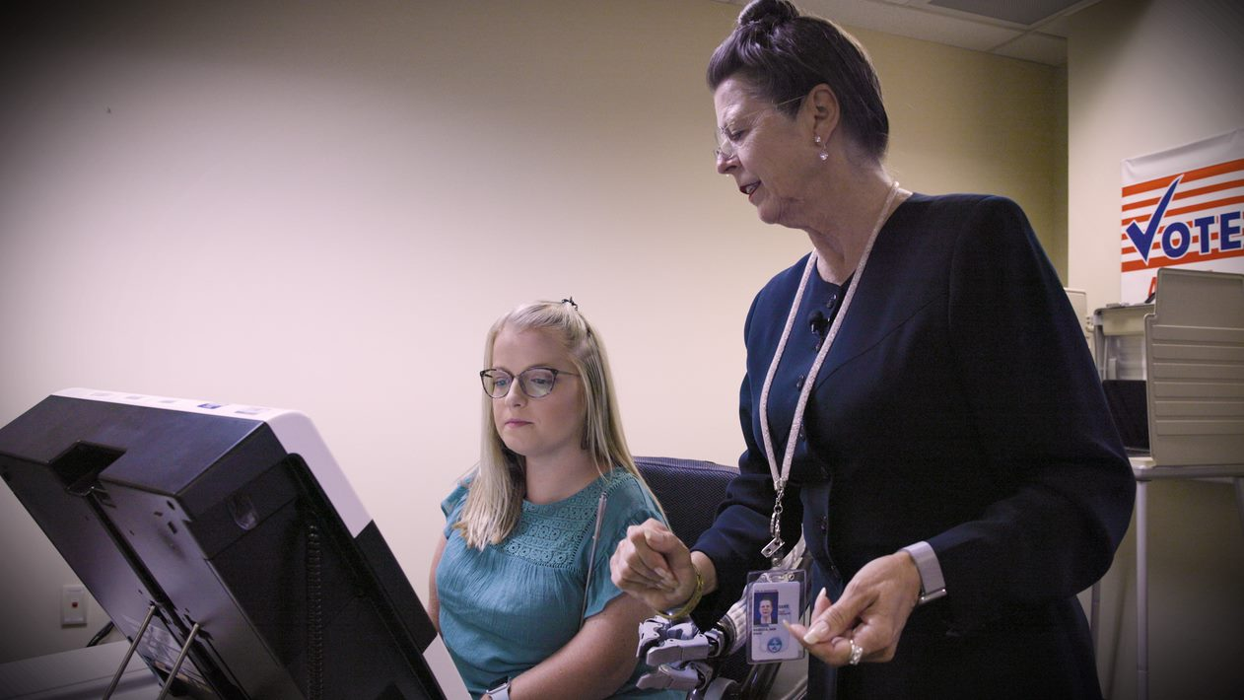
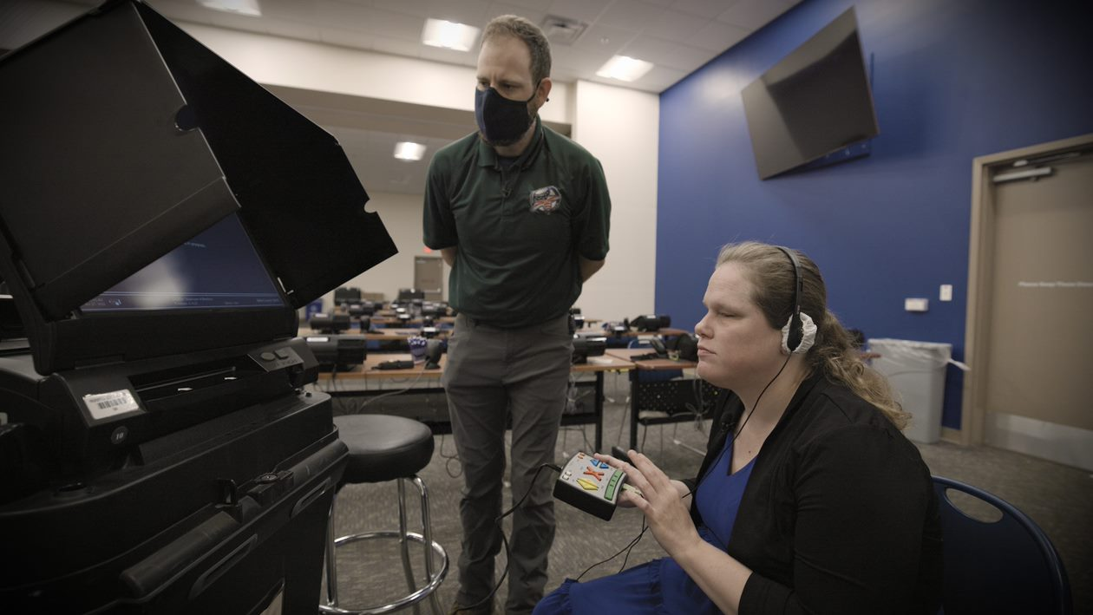

Public Forums
Disability Rights Florida (DRF) held five in-person Public Input Forums between March and June of2022.The purpose of the forums was to collect information directly from individuals with disabilities, as well as their families and service providers, to assist DRF in revising our strategic plan that determines our advocacy platform and priorities for our legal and advocacy work over the next five years. The five-year strategic plan will be in effect for the 2023 – 2027 fiscal years. The Public Input Forums were held in various locations around the state primarily to reach specific geographic locations and target constituents in three key areas: education, veteran services, and employment. We partnered with local disability organizations and held resource fairs in some locations to better reach individuals with disabilities. Most of the forums also featured a speaker related to a specific disability topic.
Due to your insightful feedback, these forums helped us set our organization’s priorities with you in mind. Your engagement set our goals demanding access and accountability in housing, transportation, employment, resource access, and mental health. We look forward to pursuing these areas of interest in the years ahead
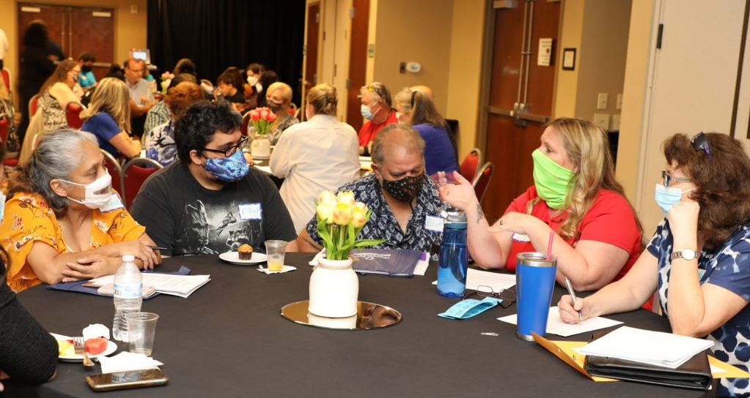

New Resources

Transition Toolkit Now Available
This year, we created a comprehensive transition toolkit and guide called “Preparing for Your Successful Transition to Adulthood, A toolkit for Florida youth with disabilities!” Within this booklet, you will find resources about assistive technology, employment, healthcare, service animals, housing, and more! Printed copies are available by calling our office at 800-342-0823 and on our website’s publications request form page. Stay tuned in 2023 for an interactive website version of this toolkit dedicated to guiding you through this formative time in your life. You deserve to thrive and easily transition into adulthood, and we want to help make that possible for every teen in Florida.
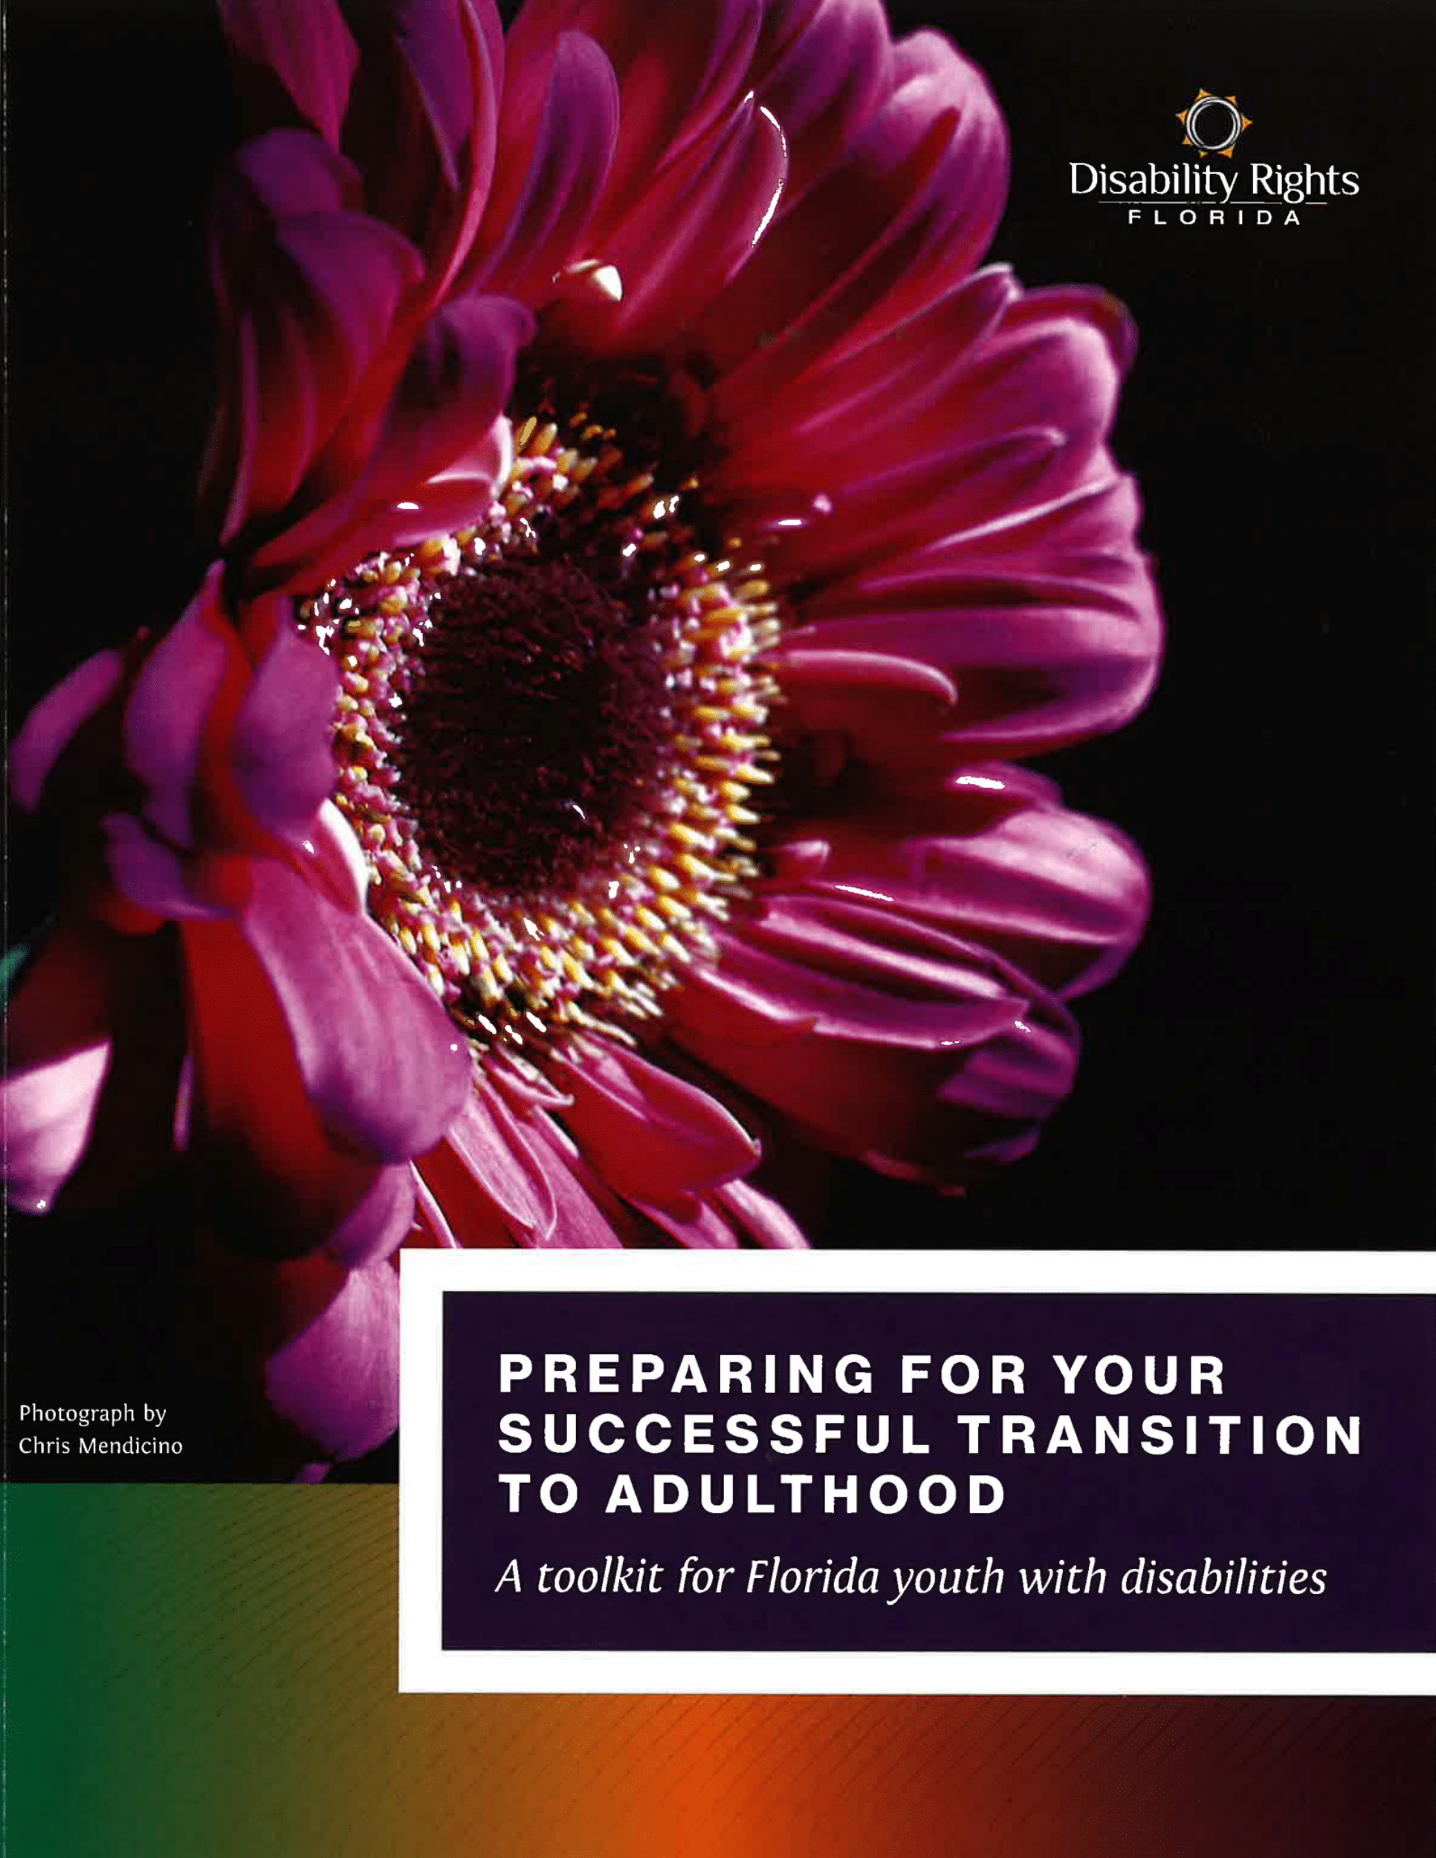

10 Steps
Effective self-advocacy is the best way to express your needs, have your voice heard, and be treated with respect and dignity. We created this 10-step guide to help you in your self-advocacy journey and help you make your voice heard. We all can be great self-advocates, and we hope this tool provides you with the support needed to take the next step in your advocacy and autonomy.
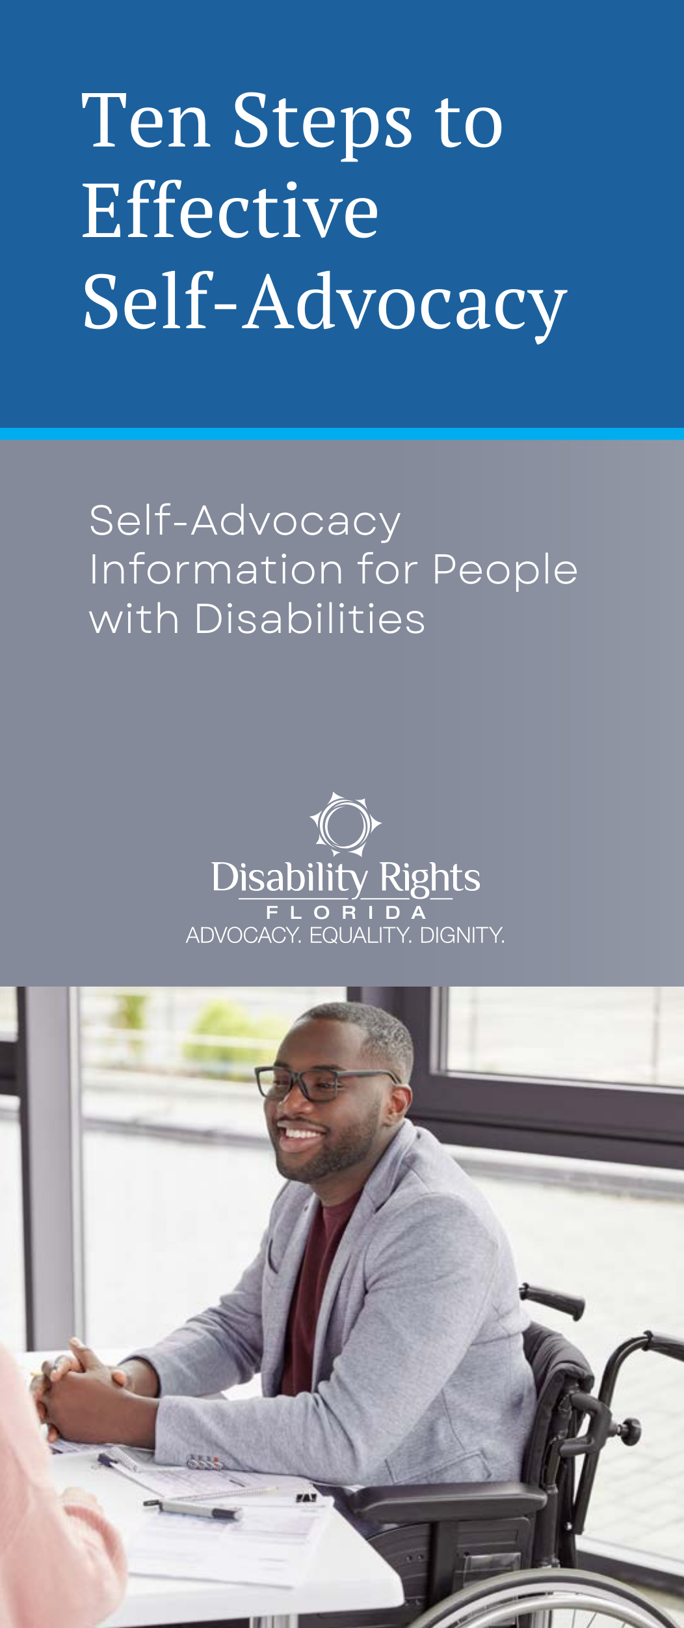

How to Complain
“How to Complain” is a three-part video series created in collaboration with other disability advocacy organizations that teaches you about the importance of self-advocacy. Self-advocates Sofia, Asim, and Corey each bring you through a moment in their lives when they faced a disability barrier and how they used their effective self-advocacy strategies to get a result that worked best for them.


Explainer Videos
Disability Rights Florida worked with an organization of talented disability artists, writers, and videographers to create videos in our series titled “Disability Rights Florida Explains” that educates the disability community about important disability- related topics.
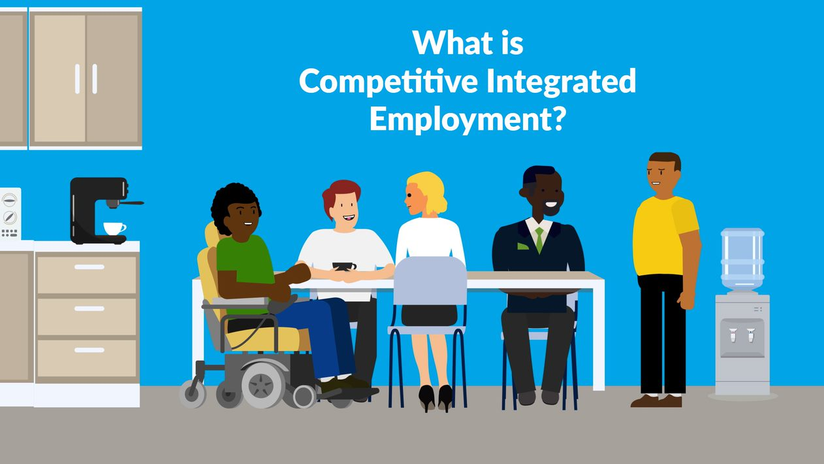
View “What is Competitive Integrated Employment” on YouTube.
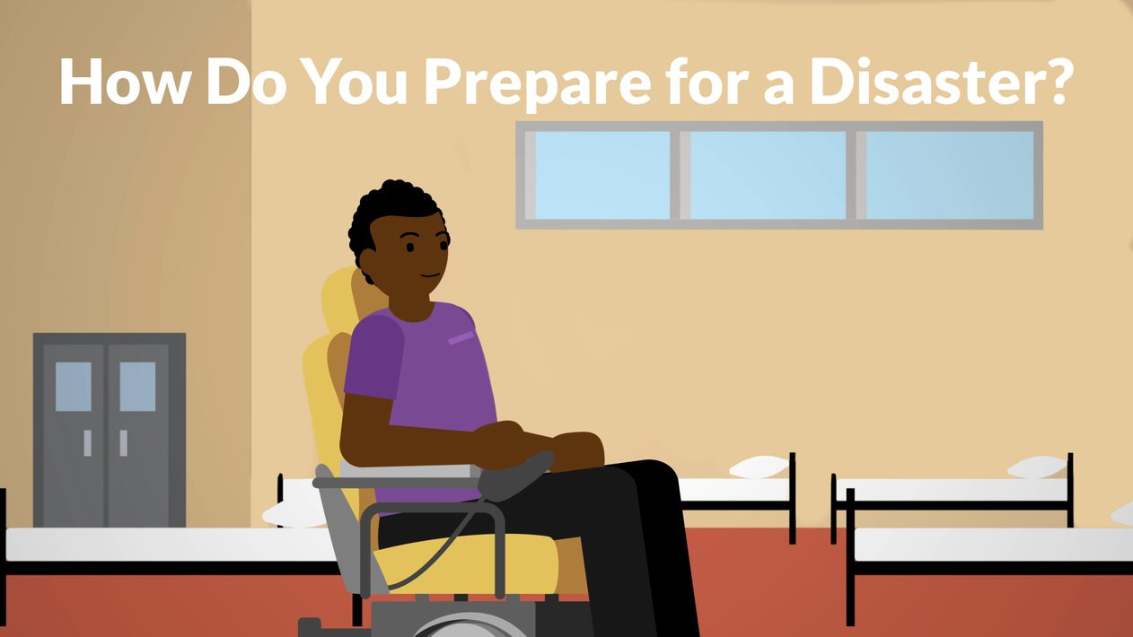
View “How Do You Prepare for a Disaster” on YouTube.
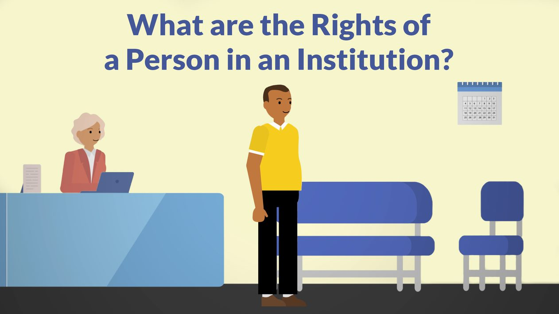
View “What are the Rights of a Person in an Institution” on YouTube.
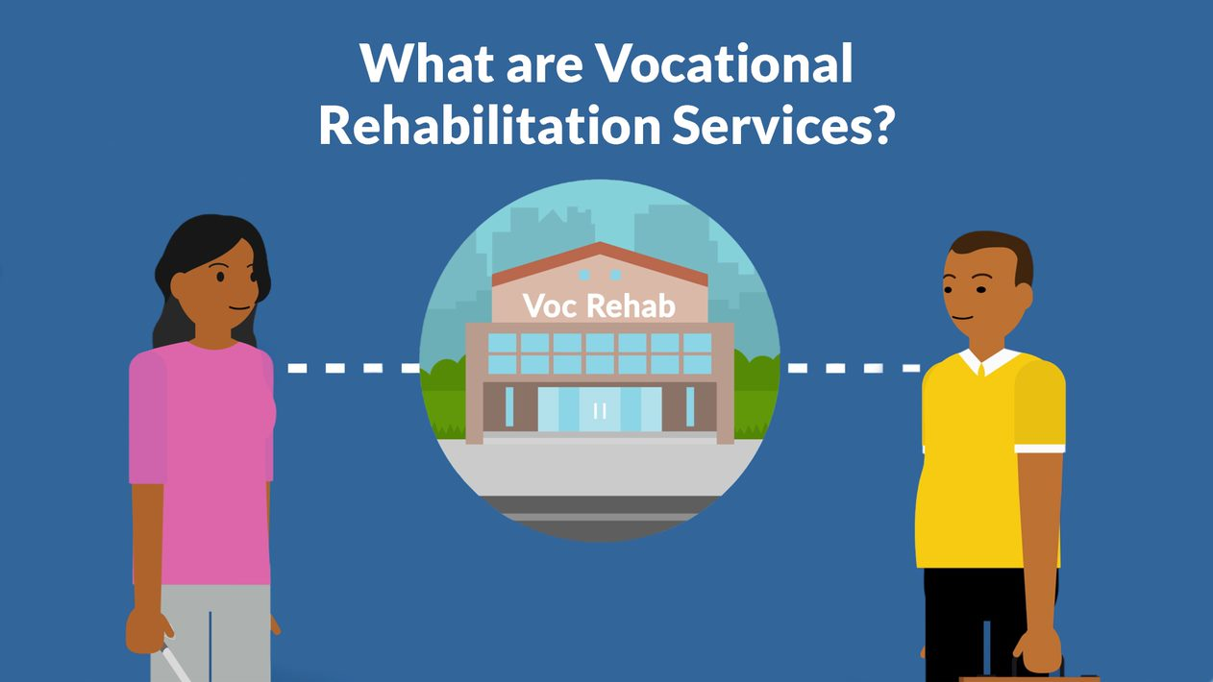
View “What are Vocational Rehabilitation Services” on YouTube.

Disability Media
The You First Podcast
Disability Rights Florida’s podcast “You First” had an incredibly successful year with episodes covering many important disability topics and issues. Previously a monthly podcast, we shifted gears in 2022 and took on recording two six-episode podcast series. Our first podcast series was called “Accessibility Outside the Box,” where we interviewed disability activists about less-discussed areas of accessibility, such as video gaming, fashion, and academic research. Our second podcast series was called “Your Voice, Your Vote.” This series was all about disability and voting. We talked with advocates who have made accessible voting possible in Florida, organizations that fight for the disability community and other marginalized communities’ access to vote, and folks who study the impact of the disability vote.
Additionally, we had a fantastic one-off episode all about “The Intersection of Disability and Reproductive Justice” with guests Morénike Giwa Onaiwu, Rebecca Cokley, Keith Jones, and Heather Watkins about how the Roe v. Wade ruling affects them, the disability community as a whole, and other marginalized groups, especially in ways that you may not have ever considered.
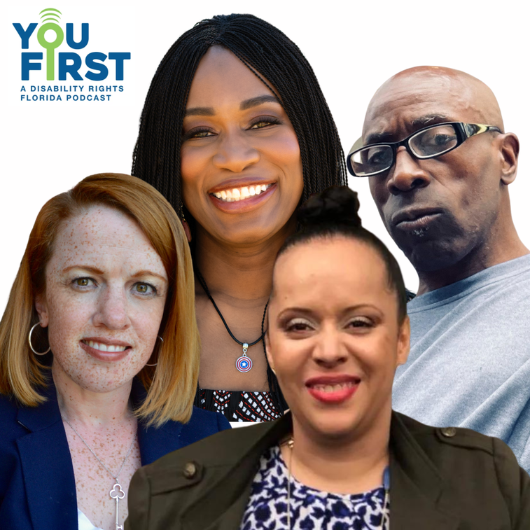
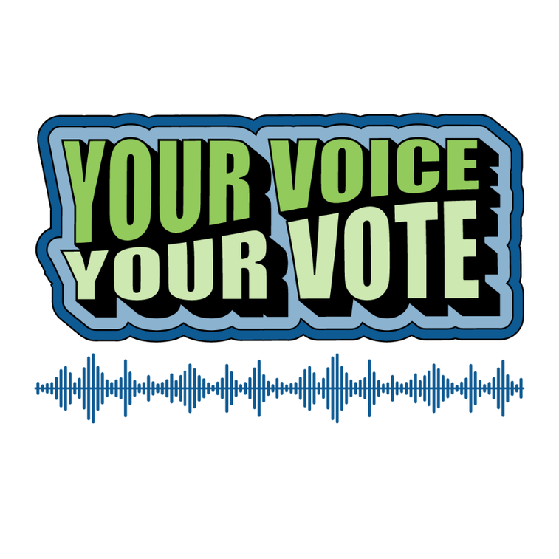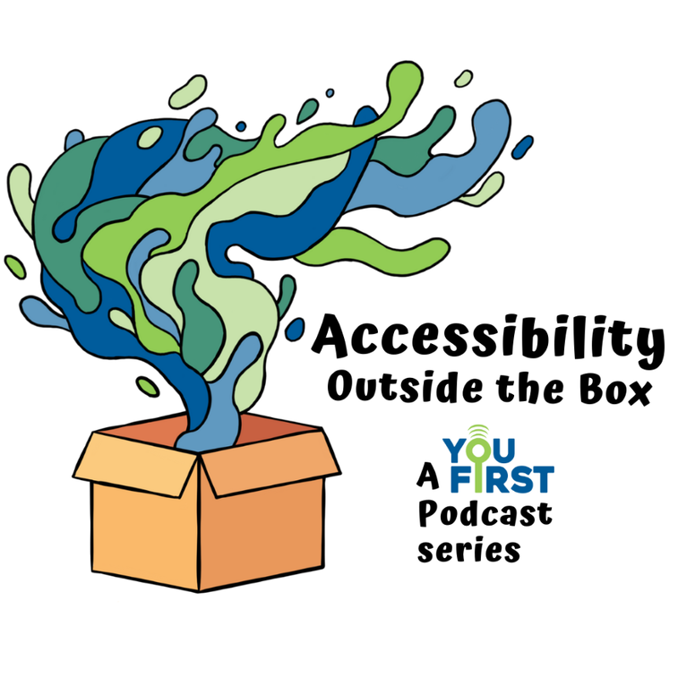

Our Blog
Each month this year, we posted at least one blog about timely disability-related news, updates about our legal work and disability advocacy, important information about your rights, cool facets of accessibility, commentary on disability media and culture, and what life with a disability is like - from disabled authors themselves. Our creative team and guest writers discuss popular topics such as disability history, special education, housing, accessibility, mental health, and much more!

Read “17 Black Disability Activists and Advocates” on our blog.
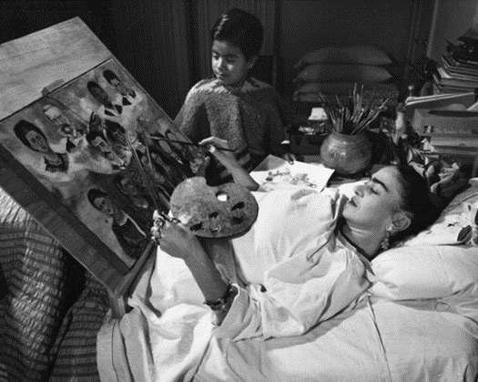
Read “Frida Kahlo’s 6 Disability Themed Paintings” on our blog.

Protecting the Rights of People with Mental Health Conditions at the Florida Supreme Court
In February, our Public Policy Analyst, Caitlyn Clibbon, argued in front of the Florida Supreme Court in order to protect the rights of Florida’s residents with mental health conditions.
The Court was considering adopting a new rule where individuals who had been involuntarily confined to a mental health facility in Florida could be forced to have their case heard remotely, over a phone or video call. This would have permitted people with mental health conditions to be institutionalized without ever seeing a court or a judge in person, even if remote participation could be harmful and inaccessible for them. Those arguing for this change said Baker Act hearings could be held remotely because of our growing understanding of technology and flexibility to do hybrid/virtual meetings. However, this posed a major concern to our organization because folks who are in these court hearings are generally those with the most intense mental health care needs.
Navigating these hearings remotely, especially depending on someone’s environment and the severity of their mental health condition, could be very disorienting for a variety of reasons. We argued that anyone who may get their liberty taken away by a court has a right to an in-person hearing if they choose. Forcing virtual hearings ignores the fact that people have the right to make their own choices about their engagement in a hearing about themselves. In-person hearings give individuals the most opportunity to participate, share their opinions, and be more present in the process. Virtual hearings can still be an option but are not a one size fits all solution. People have the right to make the decision regarding whether to join in person or virtually based on their best interest, preferences, and what would be medically necessary for them. We are happy to share that the court did not adopt the new rule forcing virtual hearings, preserving for those with mental health condition their rightful autonomy and authority in their medical and legal decisions.
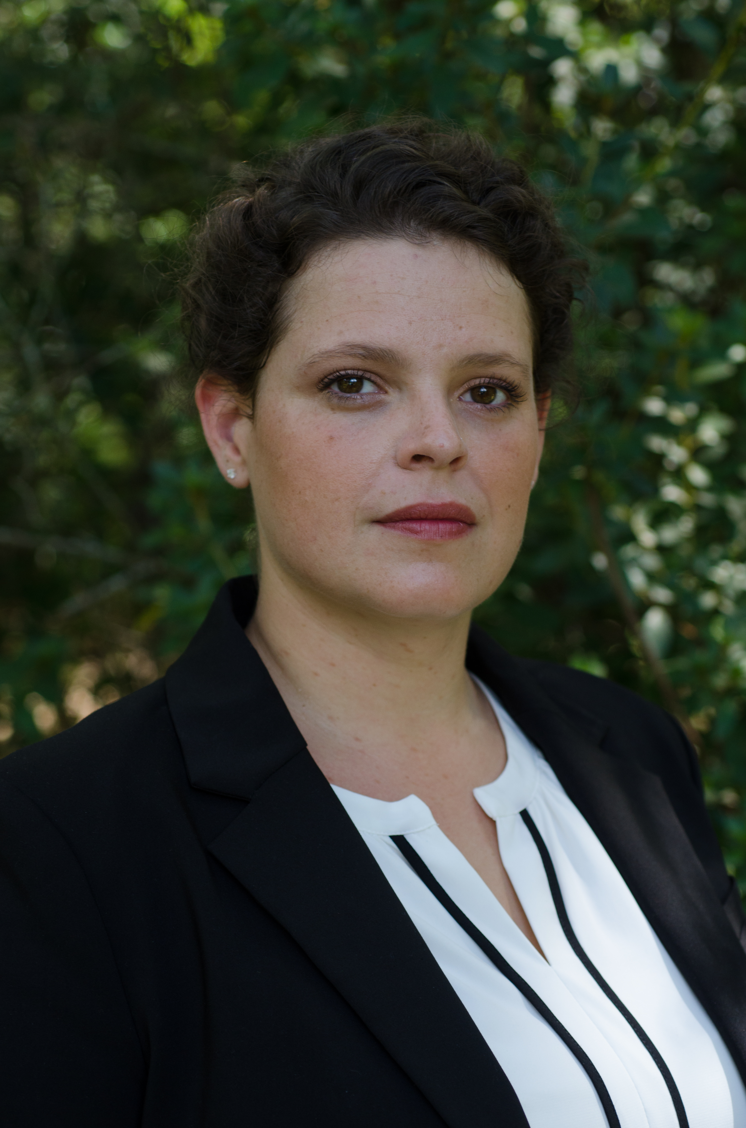
Caitlyn Clibbon, Public Policy Analyst

One Step Towards Ending Housing Discrimination For Floridians with Disabilities
In 2016, Disability Rights Florida filed a lawsuit against defendants Summit Contractors Group, Inc., Zona & Associations, P.A., Eckstein Investments, LLC., and KAE Apartments, LLC. The four defendants had violated multiple parts of the Fair Housing Amendments Act. The apartment complex, Surfside Apartments, did not have any wheelchair accessible apartments available. All available apartments were above the ground floor of buildings with no elevators and had doorways, bathrooms, and kitchens that were not accessible for individuals using wheelchairs or other mobility devices.
Their violations of the Fair Housing Act discriminated against people with disabilities and perpetuated stigma against tenants with disabilities. We are happy to share that this year, the defendants finally completed the necessary renovations to all the Surfside apartment units, making them accessible both inside and out, with features including:
- Wheelchair accessible lifts
- Accessible entry thresholds
- Accessible interior doorways
- Accessible kitchens
- Accessible bedrooms
- Accessible bathrooms
- Accessible pedestrian routes to common areas and amenities
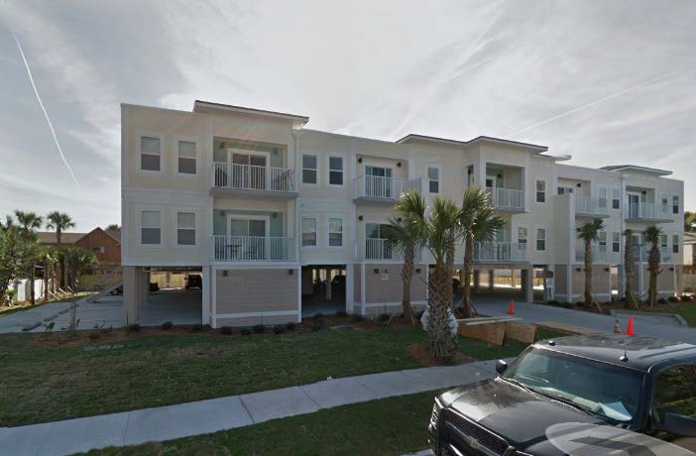

Holding Flagler School District Accountable for IDEA Violations
Disability Rights Florida filed a systemic state complaint against the Flagler County School District for violating the Individuals with Disabilities Education Act (IDEA). Flagler County School District was inappropriately removing students with behavioral needs from school without exhausting services in school, therefore not fulfilling IEP requirements or considering other less restrictive placements/environments. Additionally, the school district reduced the number of days per week transition-age students could attend school. In our systemic state complaint sent to the Bureau of Exceptional Student Education, we asked that the Florida Department of Education remedy these IDEA violations. The Department then investigated based on the complaint, and after concluding that DRF’s allegations were supported, the Department ordered the school district to take corrective action. You can read more about our work to protect students with disabilities on our website.

Our Legislative Session Work
Disability Rights Florida stayed incredibly busy in 2022 during the Legislative Session. Legislative Session is the time when policymakers and lawmakers advocate for new laws at the state capitol in Tallahassee. Our staff followed over 300 bills that had the potential to directly impact people with disabilities. We followed bills that involved important topics to the disability community including employment, student safety and privacy, supported decision-making, and mental health policy reform.
We advocated fiercely with other organizations, policymakers, representatives, and advocates to ensure that Floridians with disabilities are respected, protected and safe under the law. We will continue to demand thorough protections and equal rights for citizens with disabilities living in Florida.
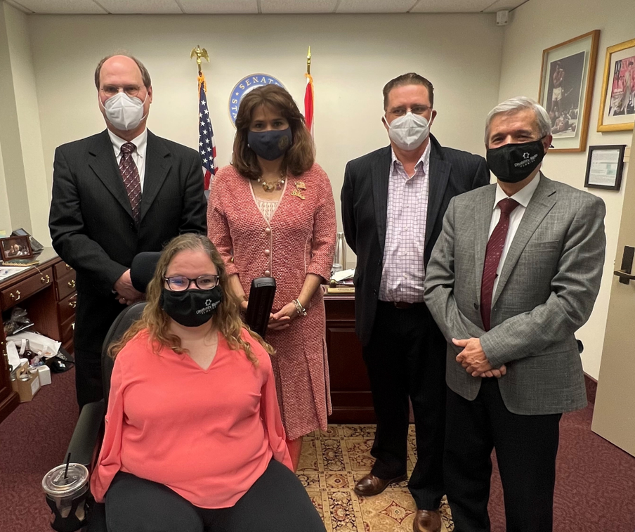
From left to right:
Peter Sleasman, Executive Director
Olivia Babis, Senior Public Policy Analyst
Annette Taddeo, Former State Senator
Kevin Sanderson, Board Secretary
Enrique Escallon, Board and PAC Member

Ensuring Access to Essential Items for Foster Care Beneficiaries
Social Security beneficiaries with disabilities living in foster care settings were going without clothes and shoes despite having adequate Social Security funds to obtain them. This was due to a breakdown in communication between the foster parents, case managers, and the Foster Community Based Care system (CBC). Foster parents’ requests for clothes, shoes and other necessary items would sometimes not reach the CBC because of staffing issues with the case managers. Using Social Security’s guidance, Disability Rights Florida worked with the case managers and the Foster CBC to create efficient policies and procedures that facilitate a timely response to a beneficiary’s request for items.

Standing in Solidarity with Florida’s Trans and Non-Binary Youth
Disability Rights Florida stands in solidarity with transgender and gender non-conforming people who were recently stripped of their right to access essential, medically-necessary gender-affirming healthcare. Disability Rights Florida is disheartened and deeply disappointed by the Board of Medicine’s newly adopted standard of care which does not allow doctors to prescribe puberty blockers and hormones, or perform surgeries, for transgender children under the age of 18. The newly adopted standard of care is wholly inconsistent with widely accepted medical practice. This change, along with the recent decision to remove coverage of gender-affirming care for all Medicaid recipients in Florida, stigmatizes transgender people and sends the message it is okay to single people out because of who they are. Disability Rights Florida adamantly opposes this restriction on Florida doctors and further states, unequivocally, that transgender and gender non-conforming people matter, are valued members of our community, and should be allowed to access medically necessary healthcare, including gender-affirming care.
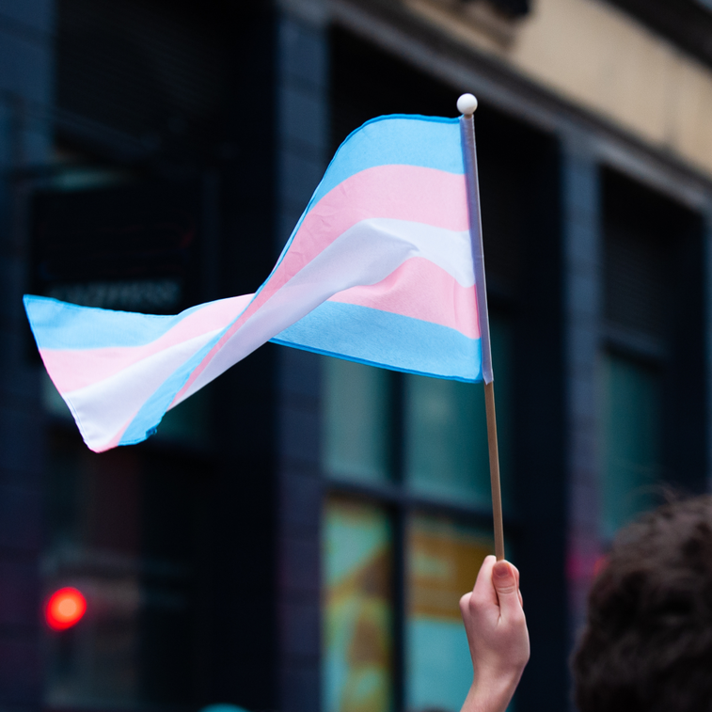

Protecting Students’ Educational Rights in Calhoun County
We filed a state complaint on behalf of students with disabilities who attend school in the Calhoun County School District. The complaint argued that the school district was violating the Individuals with Disabilities Education Act (IDEA)by failing to provide appropriate special education services to students who attend the district’s alternative education program, the CARE (Character, Attitude, Responsibility, Education) Discipline Program. Students at CARE only received computer-based instruction, using a platform that has lessons for students performing at a sixth-grade level or higher. This computer platform does not have instructional material for students who are performing below a sixth-grade level. Additionally, CARE did not have ESE (Exceptional Student Education) teachers providing direct instruction, despite having students with disabilities attending CARE that need ESE teachers. Finally, the district required students with IEPs (Individualized Education Plans) who attend CARE to essentially earn back their ESE services. The Bureau of Exceptional Student Education conducted a thorough investigation and ordered the district to correct the violations, ensuring that students at CARE have access to the special-education services to which they are entitled under the IDEA.


Financial Information

Funding Breakdown
Grant | Amount | Percentage
Assistive Technology - PAAT | $279,893 | 3%
Beneficiaries of  Social Security – PABSS | $267,595 | 3%
Client Assistance  Program - CAP | $1,052,224 | 11%
Developmental  Disabilities - PADD | $2,530,003 | 26%
Individual Rights - PAIR | $1,005,609 | 10%
Individuals with  Mental Illness - PAIMI | $2,337,307 | 24%
Traumatic Brain Injury - PATBI | $216,862 | 2%
Voting Access - PAVA | $335,038 | 4%
Social Security  Rep Payee - SPSSBA | $1,516,444 | 15%
COVID-19 Vaccine  Access - PAC5 | $155,990 | >2%
Other Grants, Donations,  and Program Income | $28,337 | >1%
Total Revenues and Support | $9,785,302 | 100%

Program vs. General and Administrative
Category | Amount | Percentage
Program Services | $9,466,555 | 89%
General & Admin | $1,146,175 | 11%
Total Expenses | $10,612,730 | 100%

New Cases by Region
Region | Cases
Northwest | 234
Northeast | 271
Central | 398
West Central | 335
Southwest | 71
Southeast | 442

New Cases by Topic Area
Topic | Percentage
Abuse & Neglect | 10%
Access & Accessibility | 11%
Benefits, Insurance, & Services | 5%
Education | 18%
Employment | 14%
Healthcare | 10%
Representative Payee Reviews | 16%
Rights Protection | 14%
Other | 2%
Total New Cases | 1,760

Board of Directors
- Virginia Daire, Chair
- Kathleen Rooney-Otero, Chair-Elect
- Kevin Sanderson, Secretary
- Richard Kottler, Treasurer
- Alan Quiles, Immediate Past Chair
- Alvin Romer, PAIMI Advisory Council Chair
- Luis Collazo
- Katherine DeBriere
- Kara Durham
- Enrique Escallon
- Eurica Ketant
- Haley Moss
- Elizabeth Perkins
- Kyle Romano
- Linda Hampton Starnes
- Elizabeth Holifield, Chair Emeritus
- Douglas Jones, Chair Emeritus
- Stephanie Preshong Brown, Director Emeritus
Peter Sleasman, Executive Director

PAIMI Advisory Council
- Alvin Romer, PAIMI Advisory Council Chair
- Dhaima Chin, PAIMI Advisory Council Vice-Chair
- Maria Bardo-Colon
- Lindsey Betterman
- Frank Blankenship
- Enrique Escallon
- Sheilah Hill
- Angel Johnson
- Deborah Larew
- Aleya Siegel
- Karina Smith
- Lauren J. Tenney
- Takita Williams

Contact Information
Disability Rights Florida
2473 Care Drive, Suite 200
Tallahassee, Florida 32308
800-342-0823
TDD 800-346-4127
www.DisabilityRightsFlorida.org
[Social Media Icons]
- Facebook
- YouTube
- Twitter
- Instagram
- LinkedIn

