Florida's Medicaid Unwinding Process

A Resource Guide in Plain Language with Pictures

What you should know about Medicaid Unwinding

 | The COVID-19 pandemic made it important for people to have health insurance. Insurance helps people who are sick pay for medical bills.
 | One type of insurance that people have is called Medicaid. Each year, people usually need to apply for Medicaid insurance.
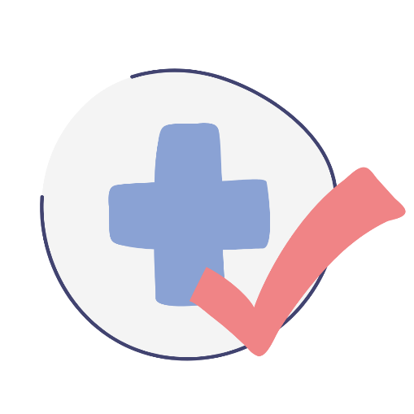 | However, since the COVID-19 pandemic started, the government let people keep Medicaid insurance, without needing to apply every year.

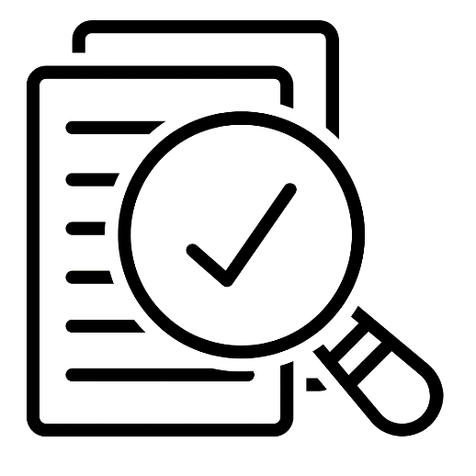 | This is now changing. In April, people will review who qualifies for Medicaid insurance, just like they did each year before COVID-19.
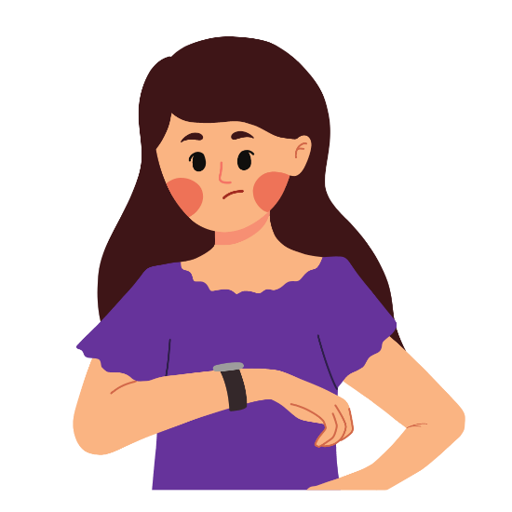 | This review process is called "Medicaid Unwinding." This process has not happened in a few years. So, the process will take longer this time.
 | It is important to know that COVID-19 is still here. Still take care of your health and let someone know if you feel sick.

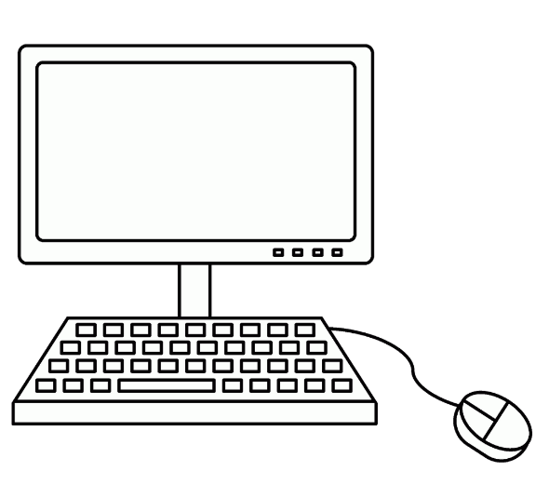 | Make sure your contact information is up to date on the Department of Children and Families website.
 | After updating your contact information, you need to wait until you receive an envelope in the mail. This envelope will have a yellow stripe.
 | The first set of envelopes will go out in April 2023. But, you may not get your envelope until a few months from now. That’s okay.

